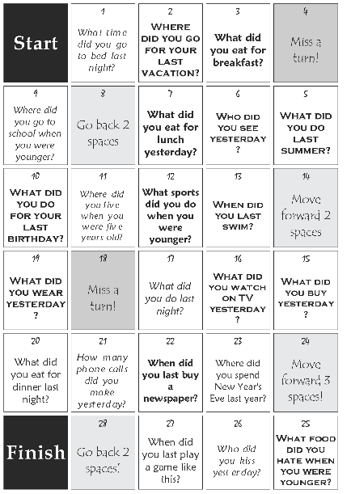
https://www.eslbase.com/images/resources/past-simple-board-game_large.png

